**PCA**

**Example-wine dataset**

**Summary of data 🡺**

|  |  |  |  |  |  |  |
| --- | --- | --- | --- | --- | --- | --- |
|  | **Alcohol** | **Malic** | **Ash** | **Alcalinity** | **Magnesium** | **Phenols** |
| **Min.** | **11.03** | **0.74** | **1.36** | **10.6** | **70** | **0.98** |
| **1st Qu.** | **12.36** | **1.603** | **2.21** | **17.2** | **88** | **1.742** |
| **Median** | **13.05** | **1.865** | **2.36** | **19.5** | **98** | **2.355** |
| **Mean** | **13.00** | **2.336** | **2.367** | **19.49** | **99.74** | **2.295** |
| **3rd Qu.** | **13.68** | **3.083** | **2.558** | **21.5** | **107** | **2.8** |
| **Max.** | **14.83** | **5.80** | **3.230** | **30.00** | **162** | **3.88** |

|  |  |  |  |  |  |  |  |
| --- | --- | --- | --- | --- | --- | --- | --- |
|  | **Flavanoids** | **Nonflavanoids** | **Proanthocyanins** | **Color** | **Hue** | **Dilution** | **Proline** |
| **Min.** | **0.34** | **0.13** | **0.41** | **1.28** | **0.48** | **1.27** | **278** |
| **1st Qu.** | **1.205** | **0.27** | **1.25** | **3.22** | **0.7825** | **1.938** | **500.5** |
| **Median** | **2.135** | **0.34** | **1.555** | **4.69** | **0.965** | **2.78** | **673.5** |
| **Mean** | **2.029** | **0.3619** | **1.591** | **5.058** | **0.9574** | **2.612** | **746.9** |
| **3rd Qu.** | **2.875** | **0.4375** | **1.95** | **6.2** | **1.12** | **3.17** | **985** |
| **Max.** | **5.08** | **0.66** | **3.58** | **13** | **1.71** | **4** | **1680** |

**Clustering before normalization of data 🡺**

1 2 3

59 71 48

**Hierarchical Clustering after normalization of data 🡺**

**method V2 V3 V4**

**1 single 59 71 48**

**2 complete 76 54 48**

**3 average 59 71 48**

**4 mcquitty 59 71 48**

**5 ward.D 59 71 48**

**6 ward.D2 59 71 48**

**7 centroid 129 1 48**

**8 median 129 1 48**

**From the above data we can say that single, average, mcquitty, ward.d, ward.D2 seems good enough for clustering.**

**Hierarchical clustering after performing PCA 🡺**

method V2 V3 V4

1 single 174 3 1

2 complete 106 22 50

3 average 125 1 52

4 mcquitty 174 3 1

5 ward.D 65 65 48

6 ward.D2 65 66 47

7 centroid 176 1 1

8 median 174 3 1

**From the above information we can infer that ward.D and ward.D2 are performing good for my clustering model.**

**Accuracy of model with PCA and without PCA 🡺**

**Cluster allocation after PCA (on row) v/s before PCA (on column)**

**For ward.D2**

1 2 3

1 59 6 0

2 0 64 2

3 0 1 46

**Accuracy 🡺0.949**

**Mis-classified 🡺67,70,74,79,84,96,122,131,135**

**For ward.D**

1 2 3

1 59 6 0

2 0 64 1

3 0 1 47

**Accuracy 🡺0.955**

**Mis-classified 🡺67,70,74,79,84,96,122,131**

**Now we are doing classification here in a unsupervised learning to calculate whether after performing PCA we are getting the same groups of cluster as before PCA or not.**

**But here class number is not relevant for our classification, we are going to see just whether these are same cluster or not after PCA.**

**K-means clustering after normalization of data**

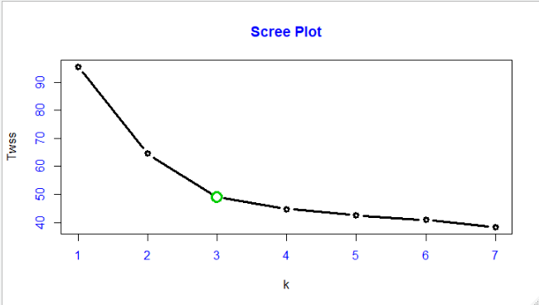

**After performing k-means clustering with k=3, we are getting below cluster size as,**

1 2 3

51 65 62

**Clusters are distributed over the three groups.**

**Comparison of Hierarchical and k-means**

HierarchicalGroup

KmeansClusterGroup 1 2 3

1 0 3 48

2 59 6 0

3 0 62 0

**From the above comparison, maximum number of group-2 k-means clusters are same in group-1 Hierarchical cluster.**

**After excepting some observations form k-means and encoding we can get following groups.**

Hierarchical_groups

Kmeans_Groups 1 2 3

1 59 6 0

2 0 62 0

3 0 3 48

**K-means clustering on PCA data 🡺**

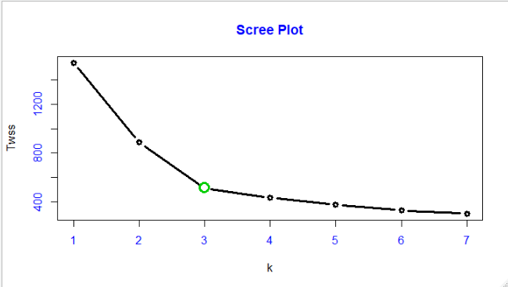

**From the above scree plot optimum cluster for k=3 and comparison**

**with all the other clusters.**

KmeansOriginal

KmeansPCA 1 2 3

1 62 1 0

2 3 61 0

3 0 0 51

**From the above information we are losing our 4% of our information, after considering the PCA.**

**Comparison with each and every method of clustering**

|  |  |
| --- | --- |
| **Clustering Method in comparison** | **Proportion of getting same cluster** |
| **K-means v/s Hierarchical** | **0.9494382** |
| **PCA_Kmeans v/s Hierarchical** | **0.96067** |
| **PCA_kmeans v/s PCA_Hierarchical** | **0.96067** |
| **PCA_kmeans v/s kmeans** | **0.9775281** |
| **Hierarchical v/s PCA-Hierarchical** | **0.9494382** |